# **IST769 Homework Submission**

Name: **Sathish Kumar Rajendiran**   
SUID: **666555028**  
Email: **srajendi@syr.edu**  
Date Due: **07/13/2021**    
Homework #:**1**

# **Exercise(s):**

1**. What would be the command to bring up the redis environment? How is the command different from the mssql environment? How is it the same?**

The command used to bring up the redis environment was “**docker-compose up -d”.** I was able to start the Redis instance on Docker container following the same. However, it has to be executed having the directory under **/srajendi/adv-db-labs/redis.** This command created a network for “redis_default” and it was running on port 6379.It used the image from docker compose.

on MSSQL, command is also the same but the directory under the execution was on **/srajendi/adv-db-labs/mssql.** In addition, mssql image was pulled from the yaml file and built the image from that repository. This reference is updated on the yml file. Later, this command created a network for “mssql_default” and it was running on default port 1433.

I was also able to run both services on the docker container.

**Evidence:**

* 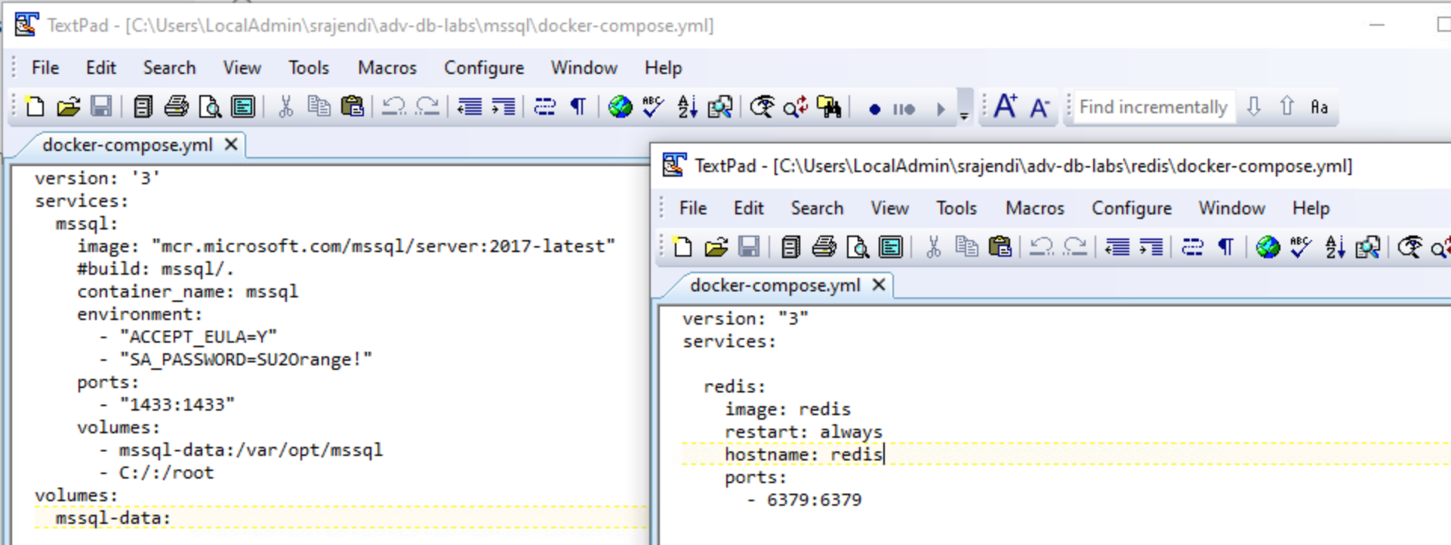
* 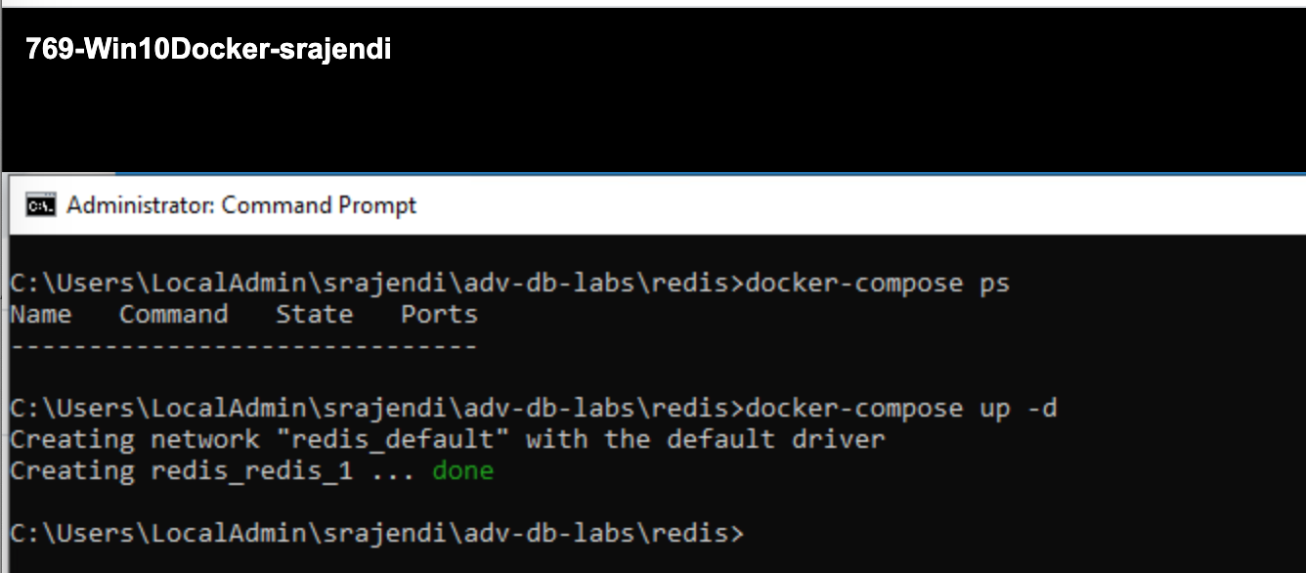
* 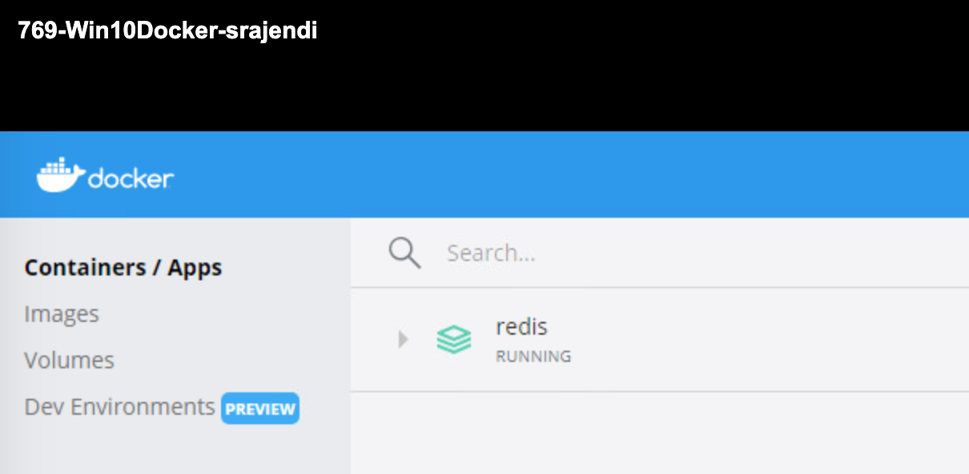
* 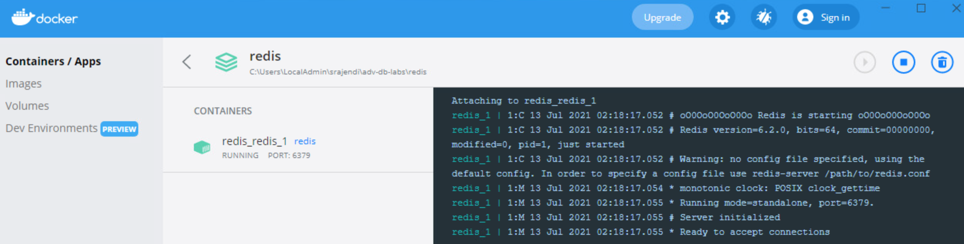
* 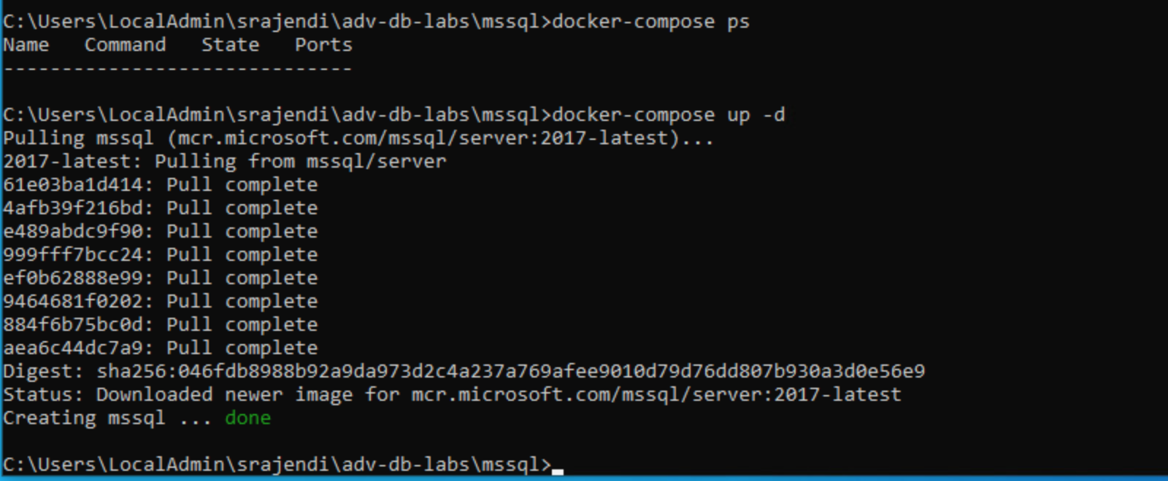
* 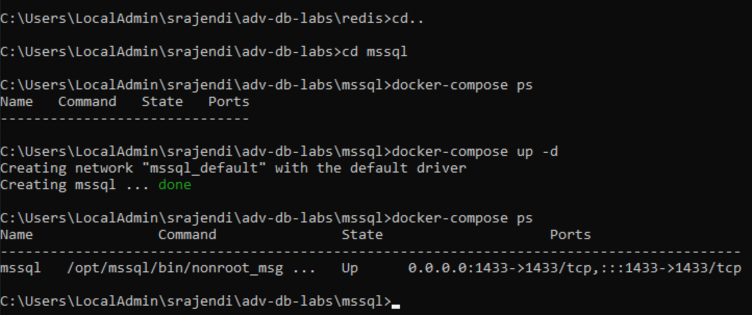
* 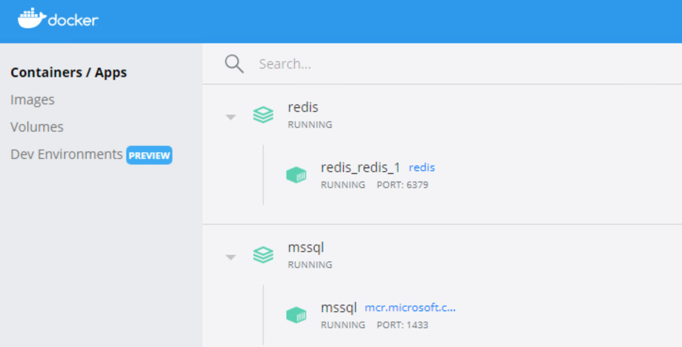

2**. Where is the specific configuration information about each environment stored?**

Configuration information about each environment is stored in “**docker-compose.yml**” file under respective components/services folder.

* 

**3. Explain the difference between stopping an environment and bringing it down. Elaborate with use-cases for each.**

* Stopping an environment:
  + Docker command: **docker-compose stop**; Whenever the services are up, executing a **stop** command would bring the services to halt state and the resources allocated would be released immediately. However, the data collected, and components created are still associated to that image and can be resumed later. This would also update the current state of the service to “Exit 0”. i.e., graciously stopping the service.
  + 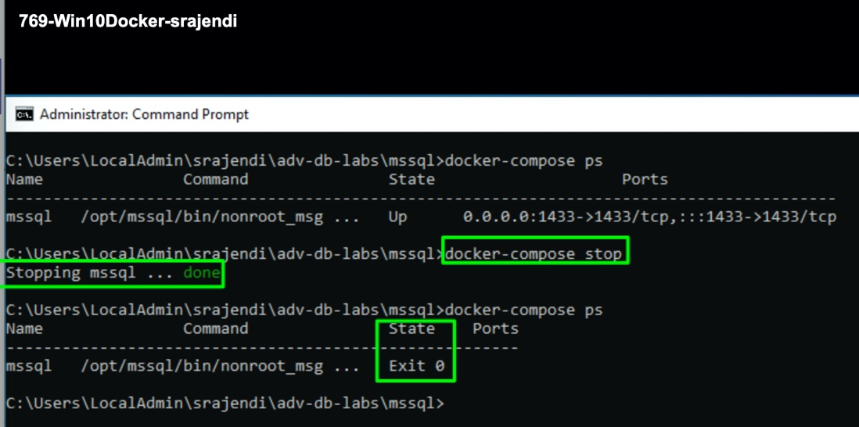
* 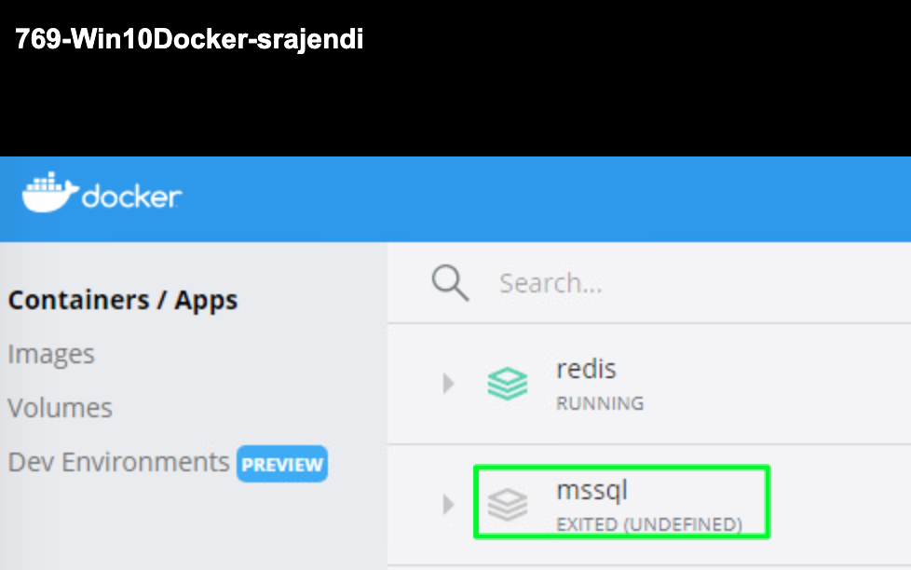
* bringing it down: **docker-compose down**
  + Whenever the services are stopped, executing a “down” command would remove the image and default network created on that port immediately. It’s a hard delete of the docker image and all the data would be lost with a successful execution. There won’t be any information on the current status if we execute the “ps” command.
  + On another hand, if we execute “down” command while having the service in running mode, it does 3 steps
    - stopping the service
    - removing the image
    - removing the network created.
  + 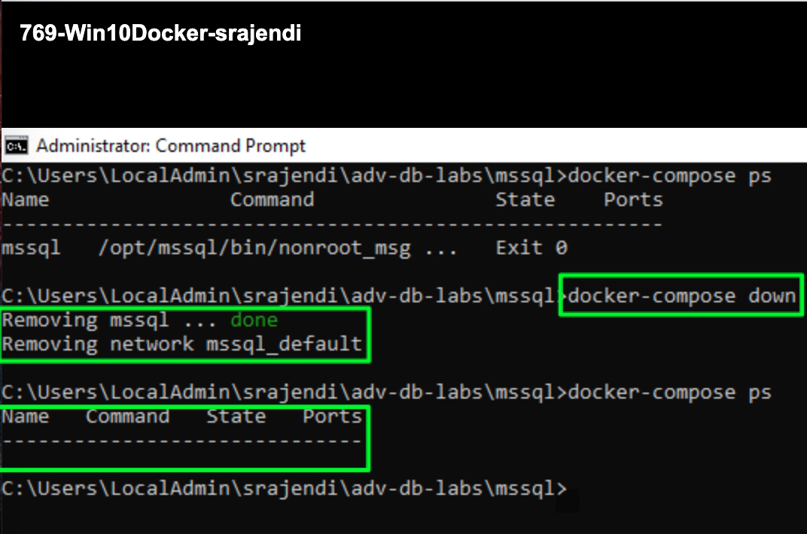
  + 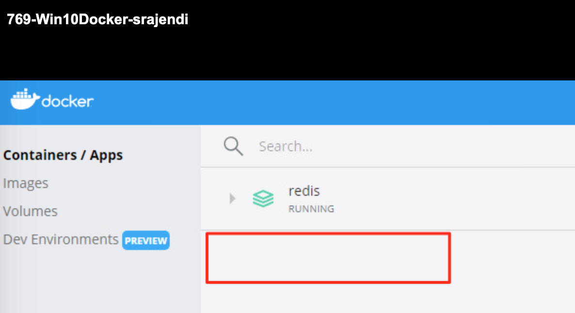
  + 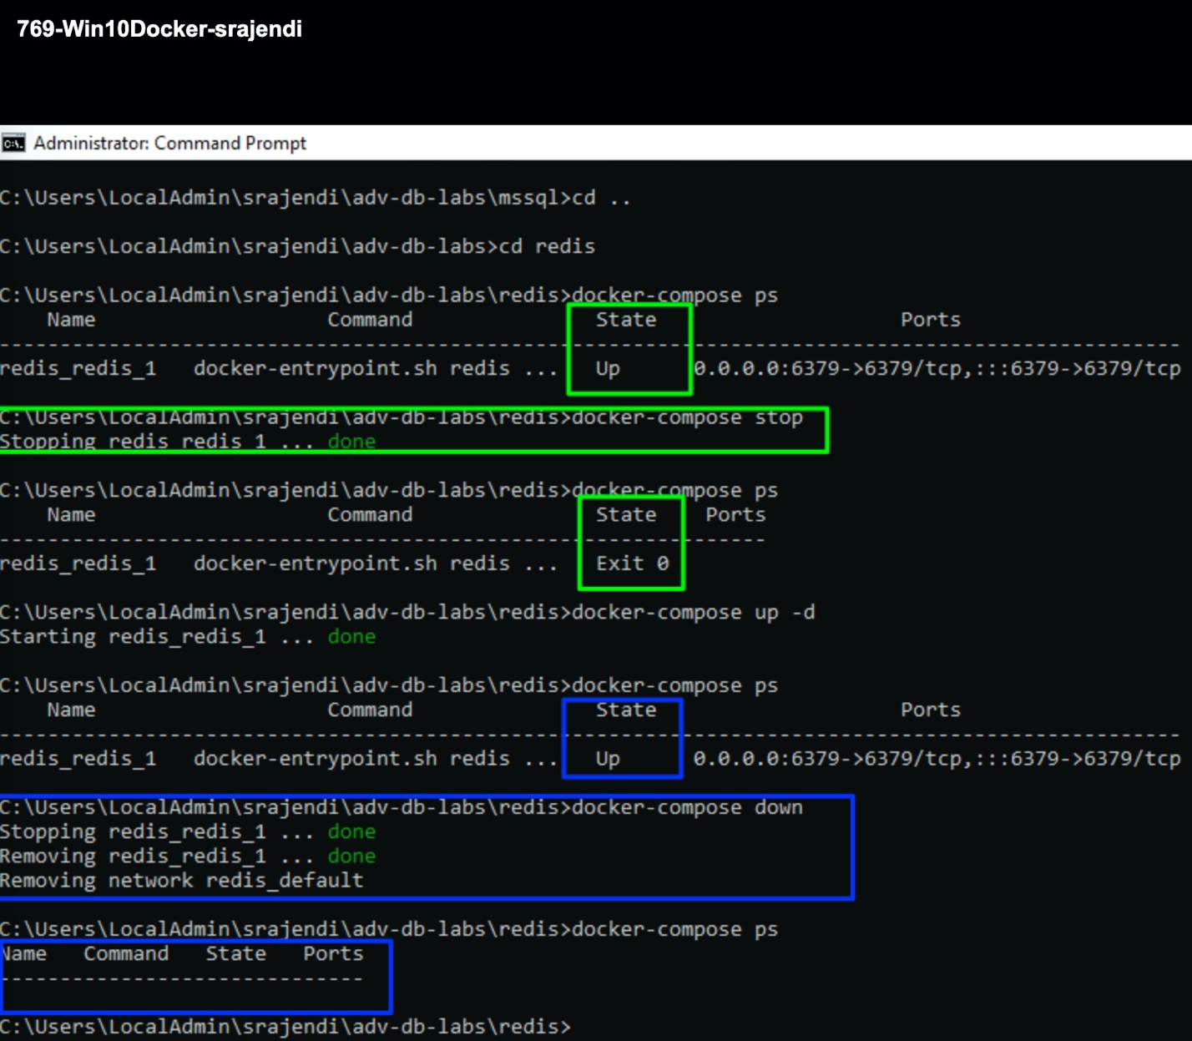

4. **What happens when you bring up an environment that is already up?**

* start the service: **docker-compose up -d;** When the service is running, executing the “up -d” command would retain the same session. It doesn’t really cause any changes to the execution state. However, it may look for any upgrades available on the image between the time it was created vs current time and might update the image. I also believe there won’t be any data/network loss as all other would remain the same. In our case, it didn’t make any impact as it returned with a status as “mssql is up-to-date”
  + 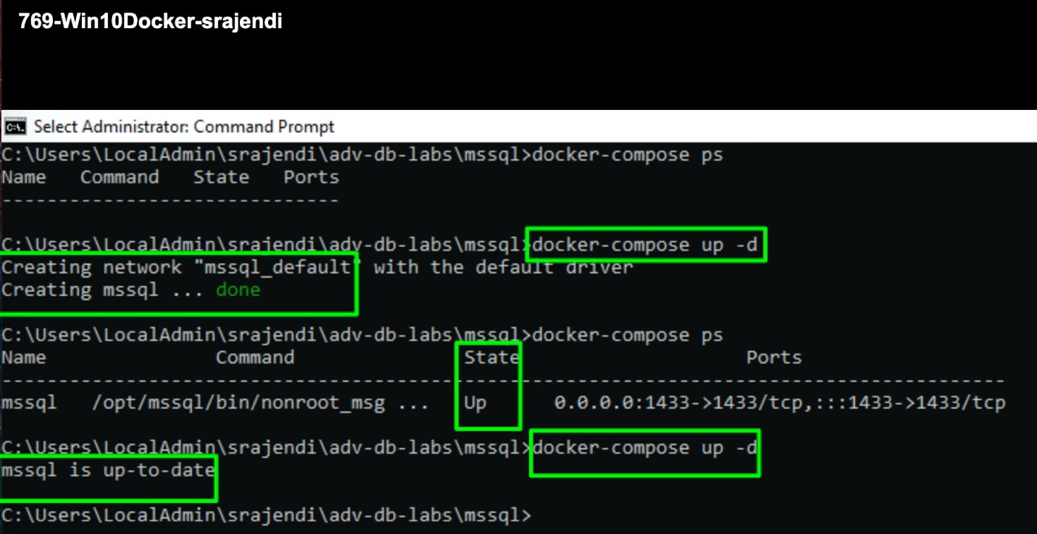
  + 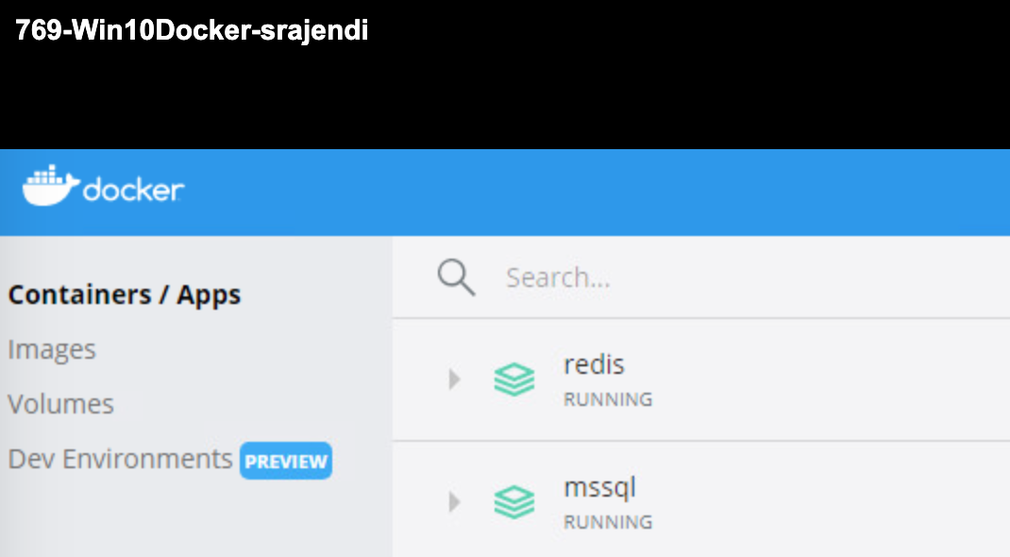

**5. What was the most difficult aspect of this lab? What changes could be made to make it less difficult?**

I don’t think it was challenging. Maybe it would have been better if we had few hands on for Redis. I personally haven’t used Redis database in the past. Only other challenge was with mssql image version. But one of the students had mentioned about the workaround to fix it. So, it was quite straightforward.

As long as vlab instance on iSchool – I am quite comfortable with this exercise. However, I would like to try to the same on my mac machine. I am not a huge fan of SQL Workbench. So, preferred MSSQL on the vlab.

**Appendix:**

